jQuery UI | draggable() and droppable() methods

**jQuery UI** is a mixture of methods and a set of user interface effects, widgets, interactions and themes which can be provided in the web page using jQuery methods. If you want to build up a powerful web application that includes various features such as dragging, dropping, date picker, tooltips, etc. then jQuery UI is perfect choice to build up these effects.  
In this article, we are going to learn about various jQuery UI interactions.

**Draggable() Method**

This method allows the elements to be dragged with the help of mouse. Using jQuery UI, we can make the DOM(**D**ocument **O**bject **M**odel) elements to drag anywhere within the view port. This can be done by clicking on the draggable object by mouse and dragging it anywhere within the view port.  
**Syntax:**  
The draggable() method has two forms and the use of each form depends on the requirement. These are as follows :-

$(selector, context).draggable (options);

$(selector, context).draggable ("action", [params]);

**The following table shows the different options that can be used with this method:**

| OPTION | PURPOSE |
| --- | --- |
| addClass | If the value of this option is set to false, it will prevent the DOM elements to be dragged . The default value this option is true. |
| axis | This option is used constrain the movement of the draggable object. If the value of this option is set to Y , then the object can be dragged in the vertical direction only and if the value of this option is set to X , then the object can be dragged into horizontal direction only. |
| containment | This option is also used constrain the movement of the draggable object within the specific region or some element.The default value this option is false. |
| opacity | This option is used to control the opacity of the draggable object while it is dragged.The default value this option is false. |

**Example:**  
In this example, the <div> with id=”d1″ can be dragged anywhere within the view port, <div> with id=”d2″ can be dragged along X axis and <div> with id=”d3″ can be dragged along Y axis.  
**Code #1:**

|  |
| --- |
| <!doctype html>  <**html**>  <**head**>  <**title**>jQuery UI Draggable</**title**>  <**link** rel="stylesheet" href="//code.jquery.com/ui/                              1.12.1/themes/base/jquery-ui.css">  <**link** rel="stylesheet" href="/resources/demos/style.css">  <**style** type="text/css">  #d1 {      width: 120px;      height: 120px;      background-color :aqua;      padding:20px;      float:left;      margin:5px;      }  #d2 {      width: 120px;      height: 120px;      background-color :orange;      padding:20px;      float:left;      margin:5px;      }  #d3 {      width: 120px;      height: 120px;      background-color :yellow;      padding:20px;      float:left;      margin:5px;      }  </**style**>  <**script** src="<https://code.jquery.com/jquery-1.12.4.js>"></**script**>  <**script** src="<https://code.jquery.com/ui/1.12.1/jquery-ui.js>">  </**script**>  </**head**>  <**body**>  <**h1**>Welcome to GeeksforGeeks</**h1**>  <**div** id="d1"><**p**>Drag Me Anywhere</**p**></**div**>  <**div** id="d2"><**p**>Drag Me Horizontally</**p**></**div**>  <**div** id="d3"><**p**>Drag Me Vertically</**p**></**div**>  <**script** type="text/javascript">  $( function() {      $("#d1").draggable();  } );  $( function() {      $("#d2").draggable({axis:"x"});  } );  $( function() {      $("#d3").draggable({axis :"y"});  } );  </**script**>  </**body**>  </**html**> |

**Output:**  
Before Dragging  
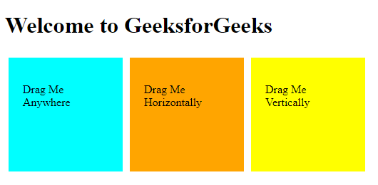

After Dragging  
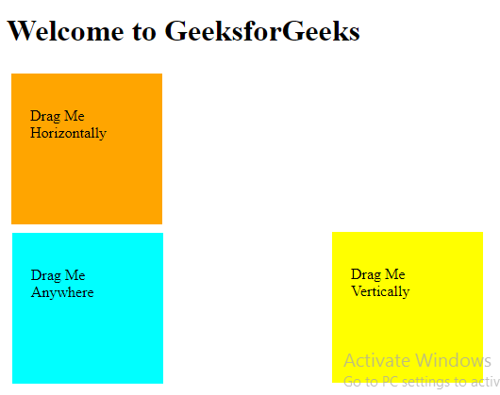

center>**Droppable() Method:**  
This method allows the elements to be dropped with the help of mouse. Using jQuery UI, we can make the DOM(**D**ocument **O**bject **M**odel) elements to drop anywhere within the view port on the specified target. This can be done by clicking on the draggable object by mouse and drop it on the specified target.  
**Syntax:**  
The droppable() method has two forms and the use of each form depends on the requirement. These are as follows :-

$(selector, context).droppable (options)

$(selector, context).droppable ("action", params)

**The following table shows the different options that can be used with this method:**

| OPTION | PURPOSE |
| --- | --- |
| accept | The value of this option specifies that which draggable objects can be dropped on the specified target. The default vaue of this option is *. |
| addClass | If the value of this option is set to false, it will prevent the DOM elements to be dropped . The default value this option is true. |
| disable | This option is also used to disable the dropppable property of the DOM element.If the value of this option is set to ture , then the object cannot be dropped and if the value of this option is set to false, then the object can be dropped on the specified target. |

**Example :**  
In this example, the <div> with id=”drag” is dragged and dropped over the <div> with id=”drop”.  
**Code #1:**

|  |
| --- |
| <!doctype html>  <**html** lang="en">  <**head**>  <**title**>jQuery UI Droppable</**title**>  <**link** rel="stylesheet" href="//code.jquery.com/ui/1.12.1/                               themes/base/jquery-ui.css">  <**link** rel="stylesheet" href="/resources/demos/style.css">  <**style** type="text/css">  #drag      {      width: 100px;      height: 100px;      float: left;      margin: 10px;      background-color :aqua;      padding:10px;      }  #drop      {      width: 150px;      height: 150px;      float: left;      margin: 10px;      background-color:yellow;      padding:10px;      }  </**style**>  <**script** src="<https://code.jquery.com/jquery-1.12.4.js>"></**script**>  <**script** src="<https://code.jquery.com/ui/1.12.1/jquery-ui.js>">  </**script**>  <**script**>  $( function() {      $( "#drag" ).draggable();      $( "#drop" ).droppable(          {              drop :function()          {              alert("I am dropped");          }          } );          } );  </**script**>  </**head**>  <**body**>  <**center**>  <**h1** align="center">Welcome to GeeksforGeeks</**h1**>  <**div** id="drag">  <**p**>Drag Me</**p**>  </**div**>  <**div** id="drop">  <**p**>Drop On Me</**p**>  </**div**>  </**center**>  </**body**>  </**html**> |

**Output:**  
Before Dropping  
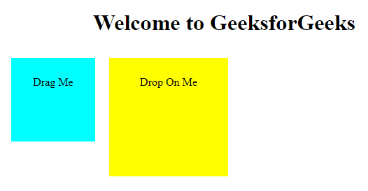  
After Dropping  
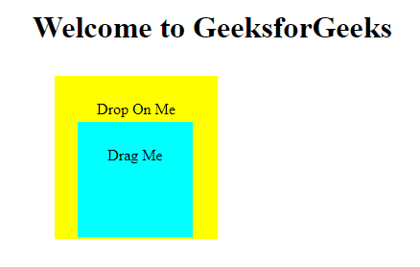  
**Code #2:**  
In this example, the <div> with id=”drag” is dragged and dropped over the <div> with id=”drop” and it cannot be dropped over the <div> with id=”non-drop”.

|  |
| --- |
| <!doctype html>  <**html** lang="en">  <**head**>  <**title**>jQuery UI Droppable</**title**>  <**link** rel="stylesheet" href="//code.jquery.com/ui/1.12.1/                               themes/base/jquery-ui.css">  <**link** rel="stylesheet" href="/resources/demos/style.css">  <**style** type="text/css">  #drag      {      width: 100px;      height: 100px;      float: left;      margin: 10px;      background-color :aqua;      padding:10px;      }  #non-drop          {      width: 100px;      height: 100px;      float: left;      margin: 10px;      background-color :orange;      padding:10px;      }  #drop      {      width: 150px;      height: 150px;      float: left;      margin: 10px;      background-color:yellow;      padding:10px;      }    </**style**>  <**script** src="<https://code.jquery.com/jquery-1.12.4.js>"></**script**>  <**script** src="<https://code.jquery.com/ui/1.12.1/jquery-ui.js>">  </**script**>  <**script**>  $( function() {      $( "#drag" ).draggable();      $( "#non-drop" ).draggable();          $( "#drop" ).droppable(          {              accept:"#drag",              drop :function()          {              alert("I am dropped");          }          } );          } );    </**script**>  </**head**>  <**body**>  <**center**>  <**h1** align="center">Welcome to GeeksforGeeks</**h1**>  <**div** id="drag">  <**p**>Drag Me</**p**>  </**div**>  <**div** id="non-drop">  <**p**>Non droppable</**p**>  </**div**>  <**div** id="drop">  <**p**>Drop On Me</**p**>  </**div**>  </**center**>  </**body**>  </**html**> |

**Output:**  
Before Dropping  
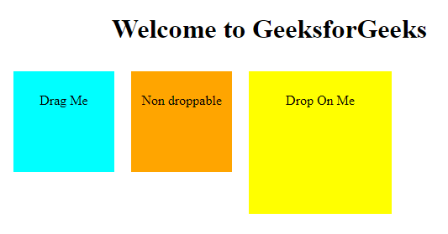  
After Dropping  
